# Management of Select Unapproved Products Coverage Strategy & Examples (Non-FDA Approved)

Reminders

Examples of Covered Products

Examples of Non-Covered Products

Frequently Asked Questions / Answers

Related Documents

**Description:** Information regarding the Federal Food, Drug and Cosmetic Act (FFDCA) unapproved drugs.

|  |
| --- |
| **Reminders** |

Over the past few years, there has been an increase in cost and utilization of products that may be marketed contrary to the Federal Food, Drug and Cosmetic Act (FFDCA).

Excluding all of these medications from coverage is not possible because it may interfere with vital prescription therapies. Using Covered Outpatient Drugs (COD) codes, we can identify medications that meet coverage requirements for Medicare Part D and Medicaid.

CVS Caremark excluded coverage for certain existing unapproved products that may be marketed contrary to the FFDCA. Coverage continues for select unapproved products that are marketed in accordance with the FFDCA or those deemed necessary to meet the clinical needs of members.

**Note:** Claims at retail that are denied due to this issue will show Reject 54: NON FDA APPROVED and NON MATCHED NDC NUMBER.

Top of the Document

|  |
| --- |
| Examples of Covered Products |

Refer to as needed:

|  |  |
| --- | --- |
| **Drug Class** | **Drug Examples** |
| THYROID | ARMOUR THYRO TAB 60 MG |
| PRENATAL VITAMINS | PNV PRENATAL PLUS TAB |
| BARBITURATE HYPNOTICS | PHENOBARBITAL TAB 32.4 MG |
| FLUORIDES | LUDENT CHW 0.5 MG F; FLUORIDE CHW 0.5 MG F |
| ANTISPASMODICS | HYOSCYAMINE SUB 0.125 MG |
| SALICYLATES (NSAIDs) | SALSALATE TAB 750 MG |
| ASTRINGENTS | HYPERCARE SOL 20% |
| CYCLOPLEGIC | ATROPINE SULFATE OPHTH SOLN 1% |
| RENAL AGENTS | Na CITRATE; K+ PHOS |



Top of the Document

|  |
| --- |
| Examples of Non-Covered Products |

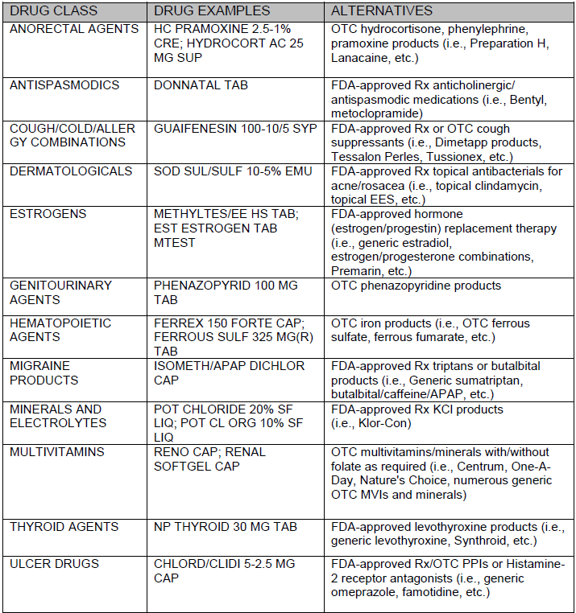



Top of the Document

|  |
| --- |
| **Frequently Asked Questions / Answers** |

Use as needed:

|  |  |  |
| --- | --- | --- |
| **#** | **Question / Statement** | **Answer** |
| **1** | What is the CVS Caremark Management of Select Unapproved Products program? | Our comprehensive strategy will limit commercial clients’ exposure to increased cost and utilization of certain unapproved products by building a systematic block at the point of sale. This strategy excludes coverage for certain unapproved drugs that have suitable clinical alternatives. It allows continued coverage of select unapproved drugs and those deemed medically-necessary under the ACA required preventive services. Commercial clients who choose not to align with this strategy can request to opt out. |
| **2** | Are there any unapproved drugs for which we are recommending coverage? | Yes. We will continue to cover certain unapproved drugs if they are legally marketed or deemed medically necessary. Excluding all “unapproved” drugs is not clinically appropriate and may risk disrupting some prescription therapy that is marketed in accordance with FFDCA. |
| **3** | Are there any unapproved products we are recommending being excluded? | Yes. We will exclude those with cost effective alternatives. |
| **4** | How will members be impacted? | Members received a letter advising that an alternative medication is available. When a member attempts to fill certain existing unapproved drugs, the claim will reject. |
| **5** | How will appeals be handled? | A denial of an exception request may be appealed through the client’s standard appeal process. |
| **6** | How will we handle members who need time to obtain an alternative? Will there be an allowance for an override? | We are not recommending overrides. A notification will be sent to impacted members in advance. This will allow them time to reach out to their prescribers for an alternative. If a client wants to put in a member override, the Account Team has to manage this process. |
| **7** | How do we notify members and physicians about this change? | CVS Caremark has letter templates that clients may use to provide advance member and prescriber notification of new coverage restrictions. Reference the sample [Member Letter (107865)](https://thesource.cvshealth.com/nuxeo/thesource/#!/view?docid=9822e730-2958-4e24-8020-1206994ef492) and sample [Prescriber Letter (107864)](https://thesource.cvshealth.com/nuxeo/thesource/#!/view?docid=c9910127-2418-4bad-bee7-d775a8bf946f). |

Top of the Document

|  |
| --- |
| **Related Documents** |

Customer Care Abbreviations, Definitions, and Terms Index (017428)

**Parent Document:** [CALL 0049 Customer Care Internal and External Call Handling](https://policy.corp.cvscaremark.com/pnp/faces/DocRenderer?documentId=CALL-0049)

Top of the Document

Not To Be Reproduced Or Disclosed to Others Without Prior Written Approval

**ELECTRONIC DATA = OFFICIAL VERSION – PAPER COPY – INFORMATIONAL ONLY**